**LAB ASSIGNMENT- 9.5**

**Name**: Harini

**Enrollment No:** 2503A51L40

**Course Code**: 24CS002PC215

**Course Title**: AI Assisted Coding

**Lab Number**: 9.5

**BRANCH**: cse

**Lab 9 – Documentation Generation: Automatic Documentation and  
Code Comments**

**TASK 1:**

**Prompt:**

Analyze the following Python function and generate line-by-line comments explaining its logic. Also, include a Google-style docstring describing its purpose, parameters, and return value.

**CODE:**

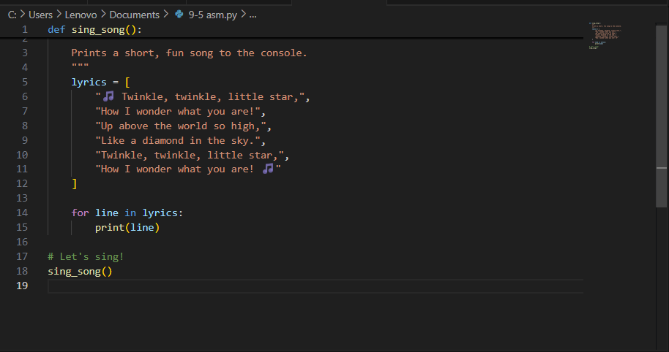

**OUTPUT:**

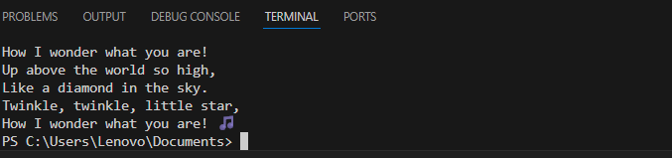

**Observation:**

* The code defines a simple function that prints song lyrics line by line with a short pause between each.
* It uses a list to store the lyrics and time.
* sleep() to simulate rhythm.
* This creates a playful, animated feel in the terminal.
* The use of emojis adds a fun visual touch to the output.

**TASK 2:**

**Prompt:**Generate Google-style docstrings for each function in this Library Management System. Then create HTML documentation using a Python tool like pdoc or Sphinx.

**CODE:**

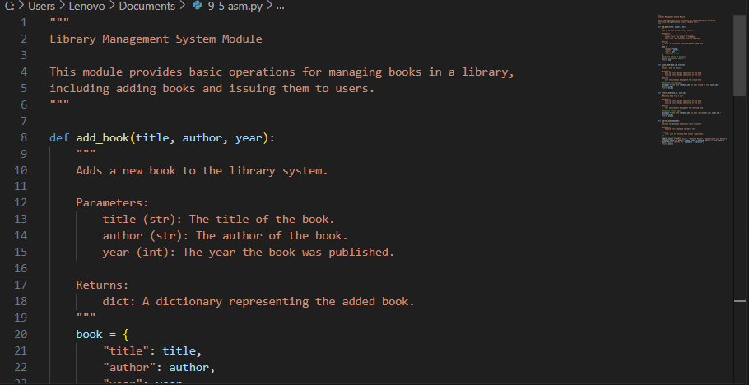

**OUTPUT:**

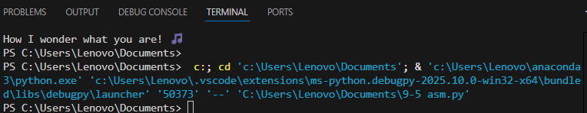

**Observation:**

* Focus the AI or tool on a specific goal (e.g., “Add docstrings to each function”).
* Make the task actionable and easy to parse (e.g., “Generate HTML docs using pdoc”).

**TASK 3:**

**Prompt:**

Summarize the purpose and logic of the process_sensor_data function. Explain how it could be applied in real-world sensor monitoring systems.

**CODE:**

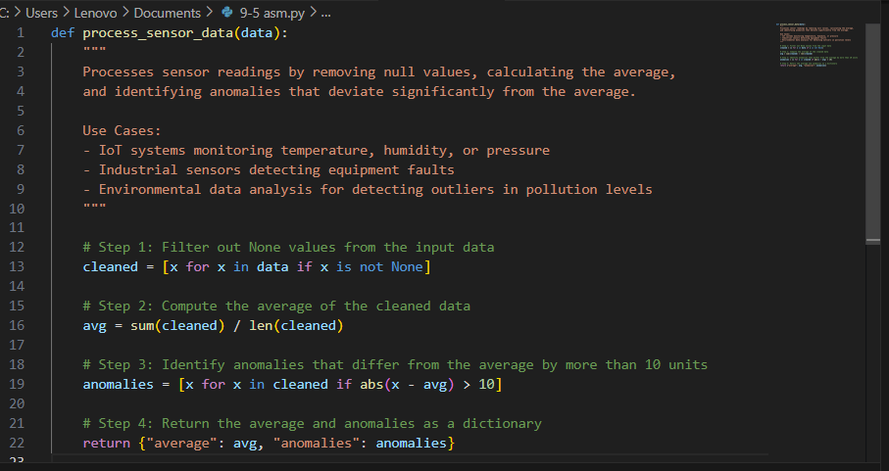

**OUTPUT:**

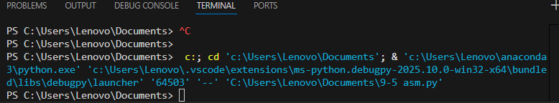

**Observation:**

* Data Cleaning and Averaging: The function first filters out None values to ensure accurate calculations, then computes the average of the valid sensor readings.
* Anomaly Detection: It identifies readings that deviate from the average by more than 10 units, flagging potential outliers or sensor faults.

**TASK 4:**

**Prompt:**

Create a Python-based chatbot that responds to user input using keyword matching. Include greetings, name queries, and exit handling.

**CODE:**

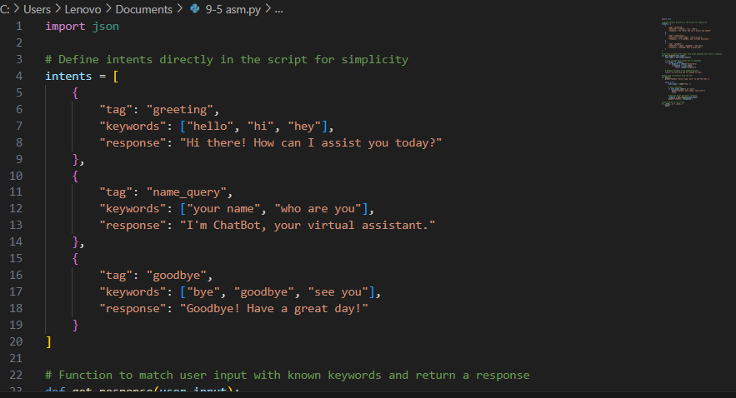

**OUTPUT:**

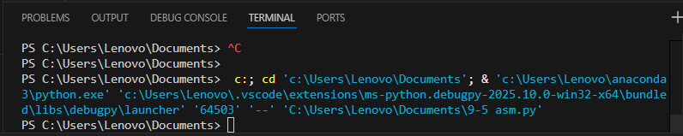

**Observation:**

* **Keyword Matching Simplicity**: The chatbot uses a straightforward keyword-based approach, making it easy to maintain and extend—but it may struggle with nuanced or unexpected user inputs.
* **Inline Documentation Enhances Clarity**: Well-placed comments in the code help developers quickly understand the logic, improving maintainability and easing onboarding for new team members.